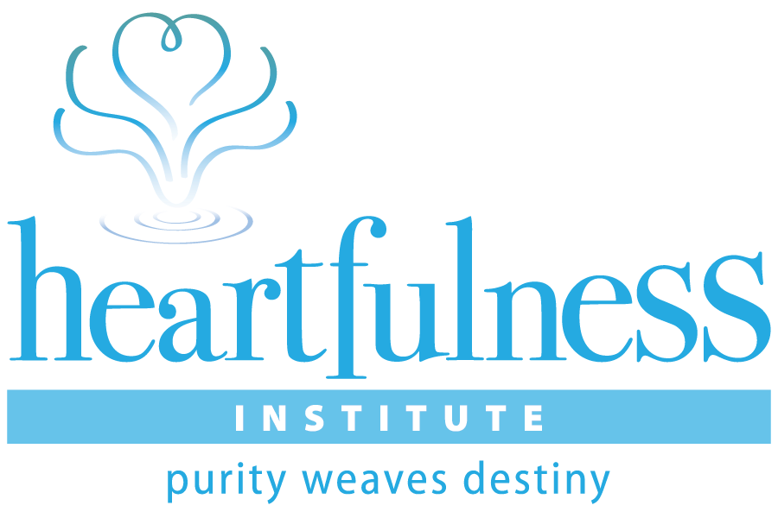

DISCLAIMER

Heartfulness Institute (“HI”) makes its relaxation, meditation and spirituality programs (“Programs”) available at no charge to all seekers, including individuals who may be dealing with personal health issues (“Participants”). HI offers these services in an attempt to help Participants cope with what is likely a particularly stressful time in their lives. However, HI stresses and Participant acknowledges that utilizing the Program’s teachings and practices are not intended to be and in fact are not substitutes for timely care by qualified medical professionals
Participant further acknowledges and agrees that he or she has no claim or cause of action arising from any mistaken assumption that the Programs are in any way intended to be a substitute for proper medical care addressing Participant’s specific health issue(s).

HEARTFULNESS GUIDED RELAXATION
FAMILY CAREGIVERS
Sit comfortably and close your eyes very softly and very gently.
Let's begin with the toes. Wiggle your toes. Now feel them relax.
Relax your ankles and feet. Feel the healing energy of Mother Earth move up your feet to your knees relaxing the legs.
Relax your thighs. The healing energy moves up your legs... relaxing them.
Now, deeply relax your hips... stomach ... and waist.
Relax your back. From the top to the bottom the entire back is relaxed.
Relax your chest … and shoulders. Feel your shoulders simply melting away…
Relax your upper arms.
Relax each muscle in your forearms ...
your hands... right up to your fingertips.
Relax the neck muscles. Move your awareness up to your face.
Relax the jaws... mouth ... nose ... eyes ... earlobes ... facial muscles ... forehead ... all the way to the top of your head.
Feel how your whole body is now completely relaxed.

For all those of you who are family, or caregivers, bring your attention to your heart....visualize your loved ones getting better and stronger...stay here with this thought....
for all those who are here for treatment…..

Slowly and gently move your attention to the organs or area of your body affected by the disease.
Visualize these organs or the area and bring your awareness there.
The energy is now flowing into these organs. Let them be bathed in this sacred, divine energy.
Suggest to yourself that this loving energy is healing your organs.
Rest here in the awareness that your organs are receiving this healing energy.
Move your attention to your heart.
Rest there for a little while.

Now everybody join together and ..
Feel immersed in the love and light in your heart.
Remain still and quiet, and slowly become absorbed in yourself.
Remain absorbed within for as long as you want, until you feel ready to come out again.

www.heartfulness.org

